Election Ballot for Officers Positions with The Dominican Bar Association, Inc. (the “DBA”)
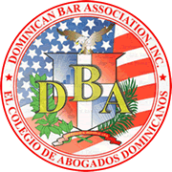
Election Date and Location:
August 22, 2018
6:30 p.m.
Anderson Kill
1251 Avenue of Americas
New York, New York 10020
DIRECTORS: | Set forth below are the officers positions up for election with the DBA, as well as the names of the candidates running for them. Please circle the name of the candidate for whom you wish to vote. None of the positions are contested.

Position Candidate
President for January 2019 Term | Marbel L. Munoz

